Openshift virt setting up in single node using HPP
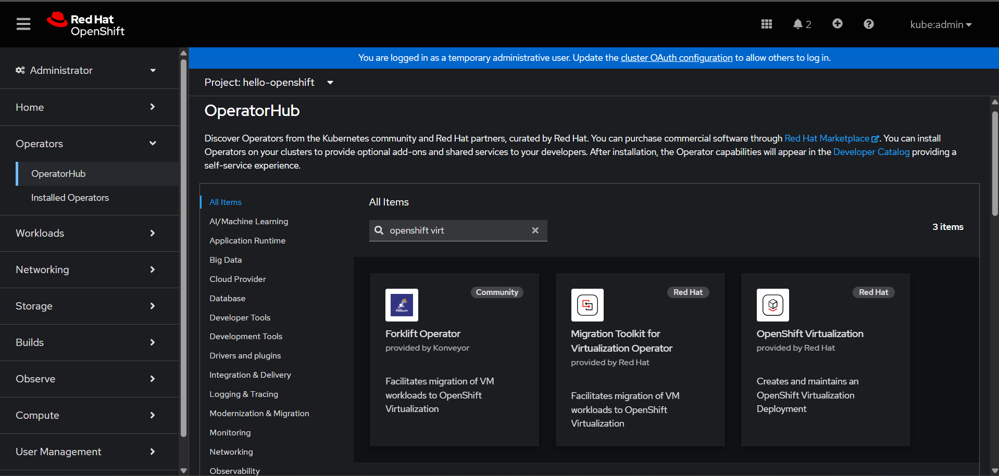
Install openshift virtualization operator.
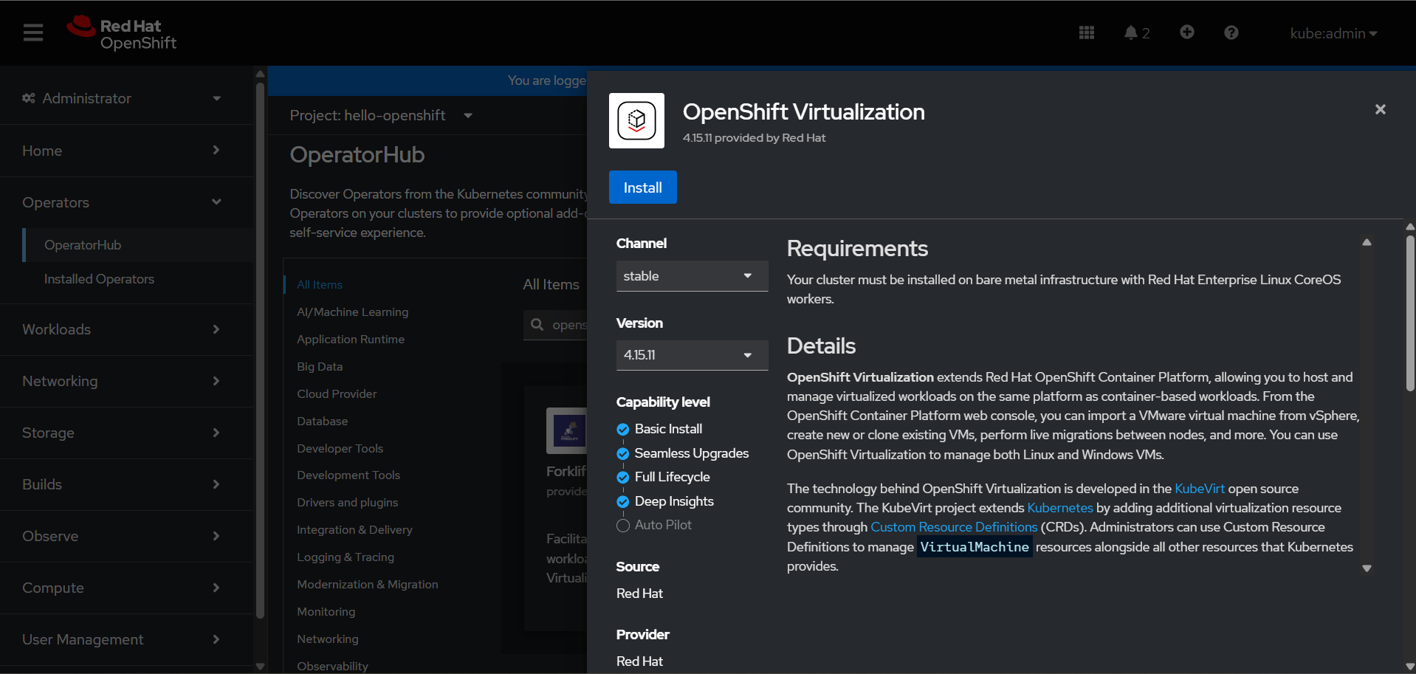

Select the version of ocp virt operator need to deployed and namespace or other details.
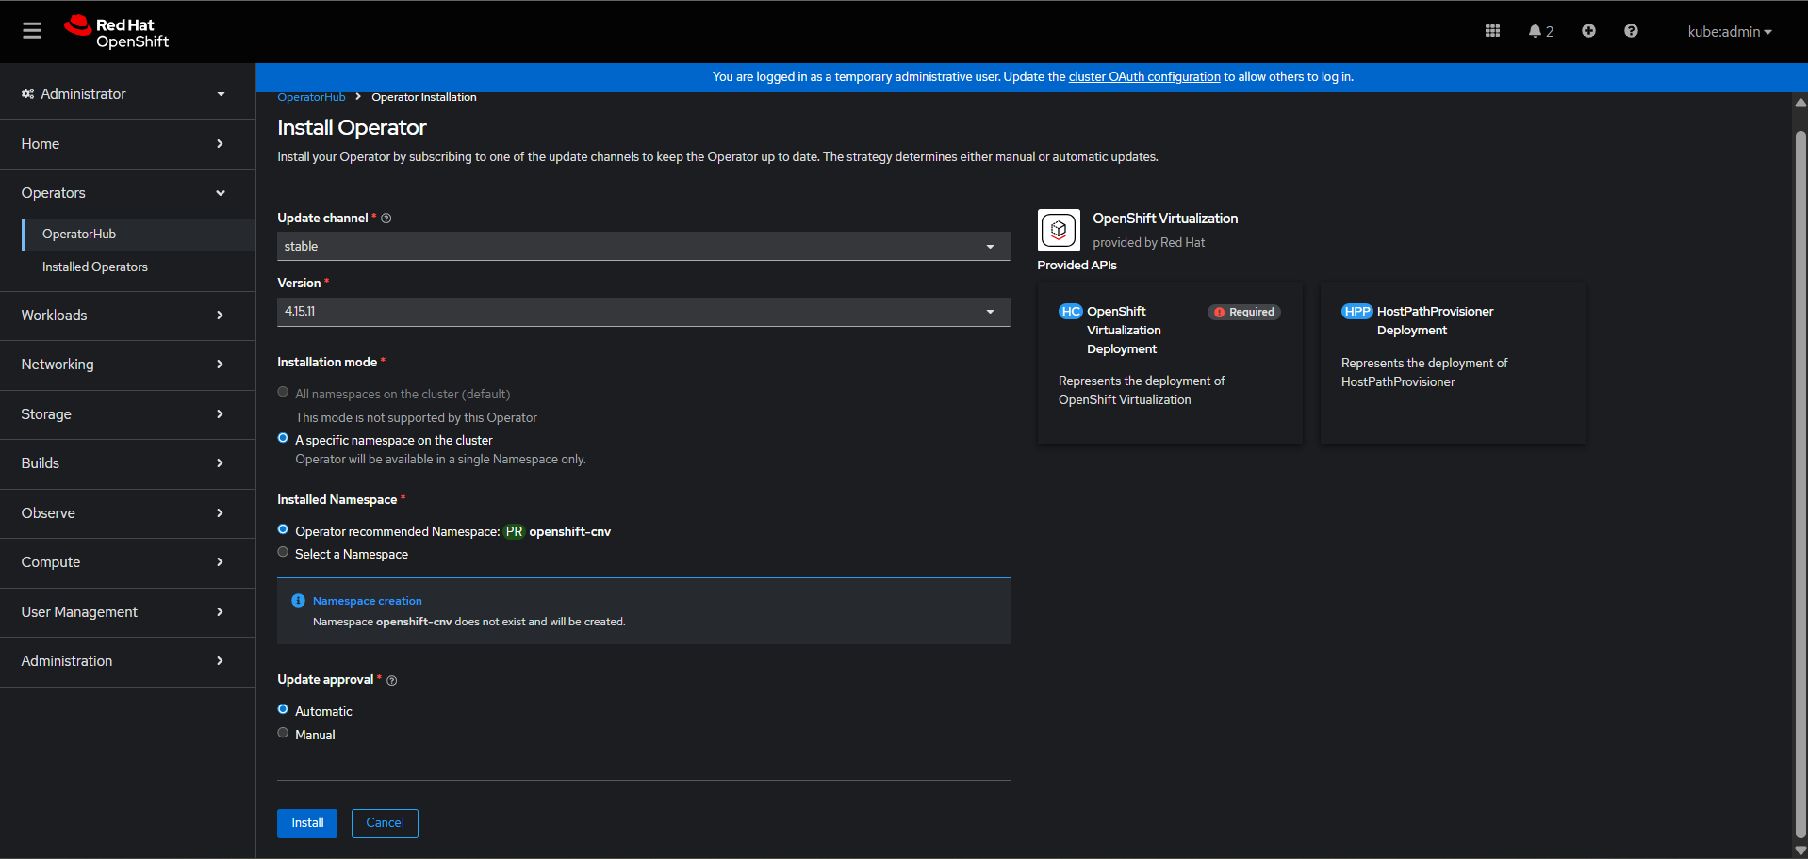
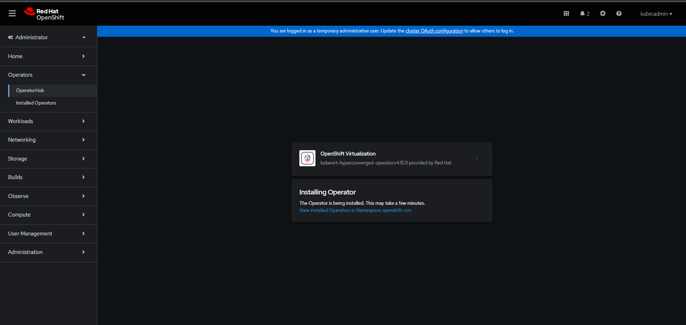

Once installation of operator is completed then start creation of HyperConverged.
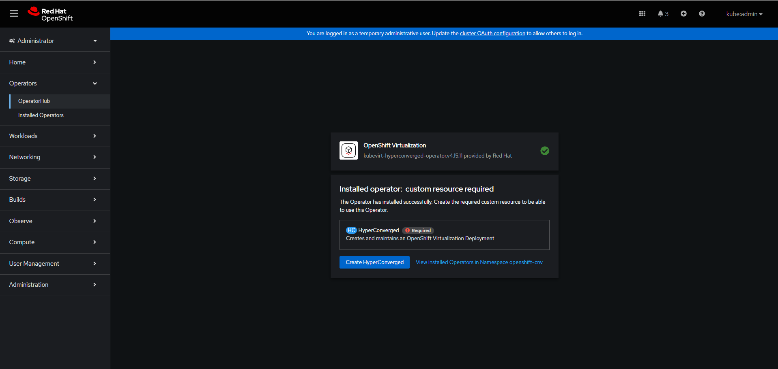
Select the yaml form and select the create option.
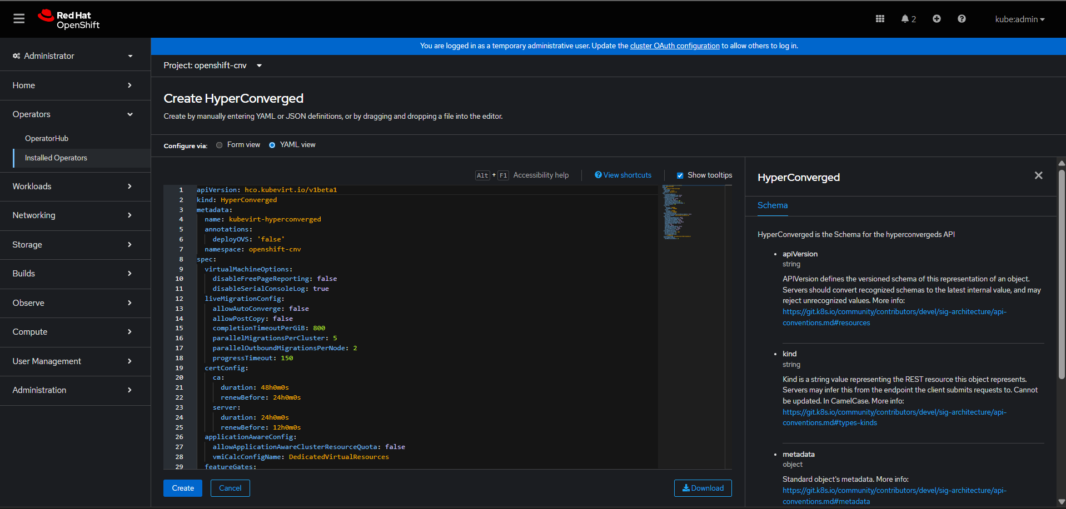

Monitor the status wait till it come to available state
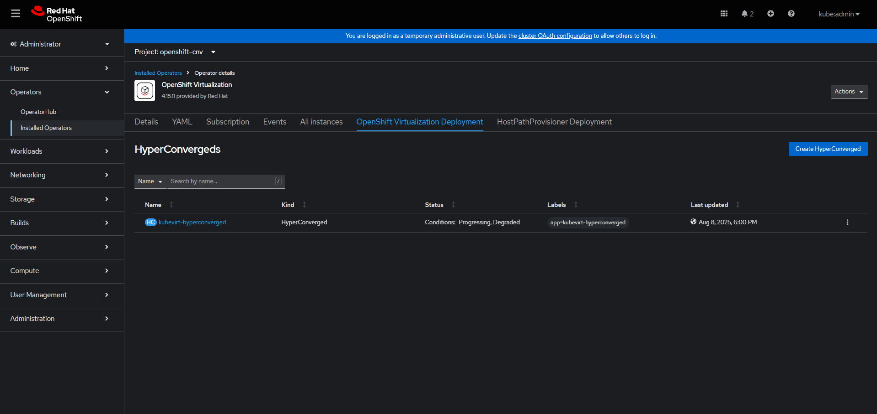
It will ask for the refresh the console once you refresh the console virt tab will be visible.
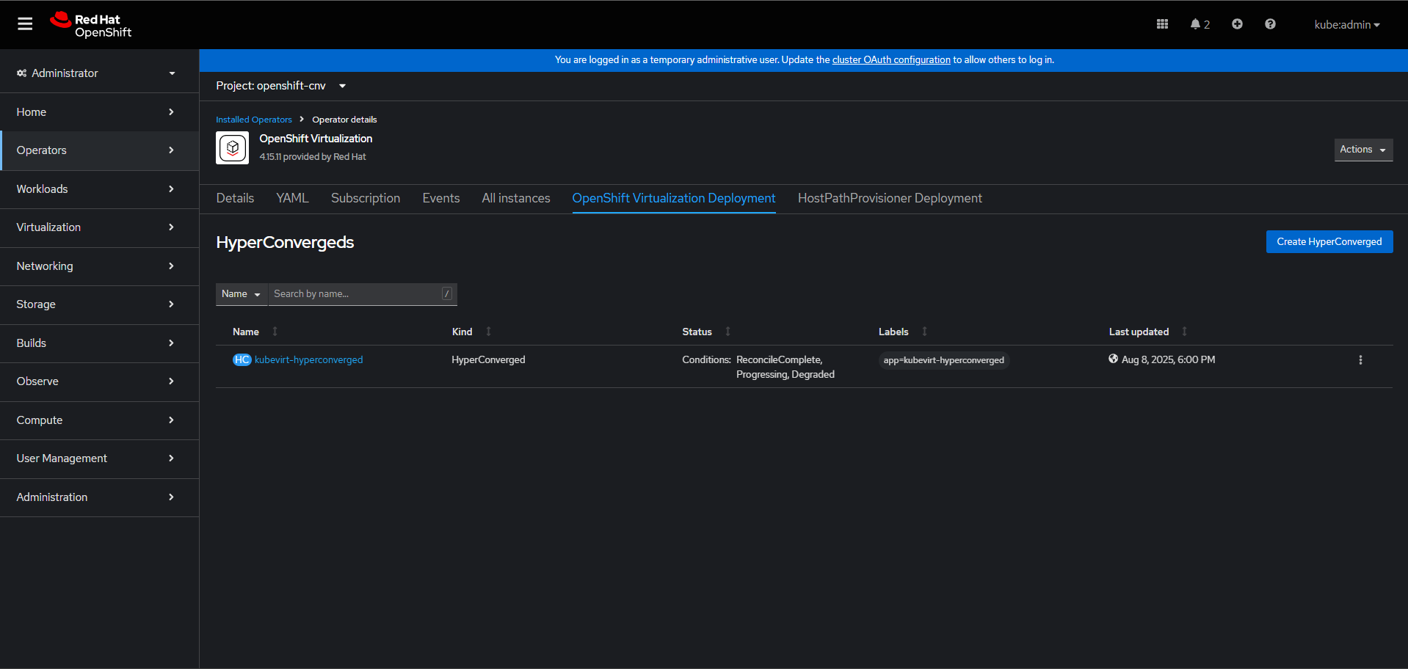

Next is we need to create the hpp.
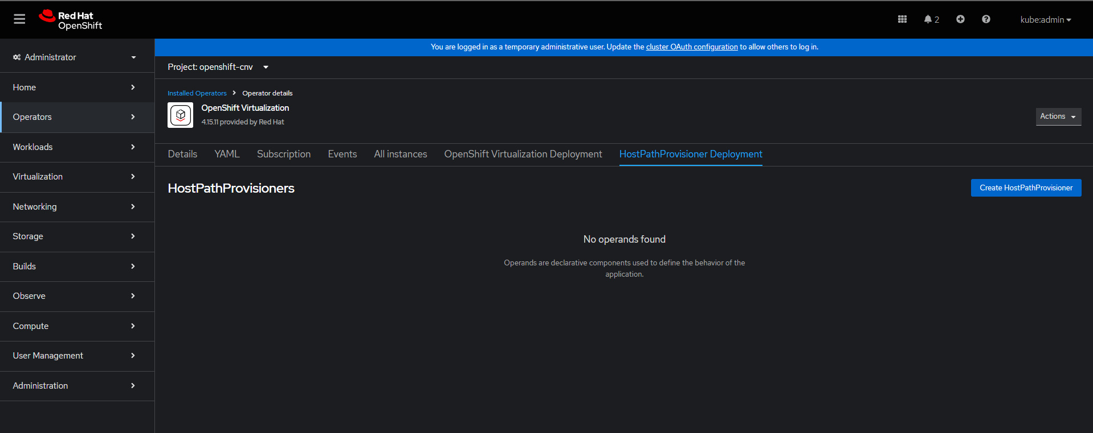
Take the access of node and create a folder with the name of /var/hpvolumes and give 777 permission
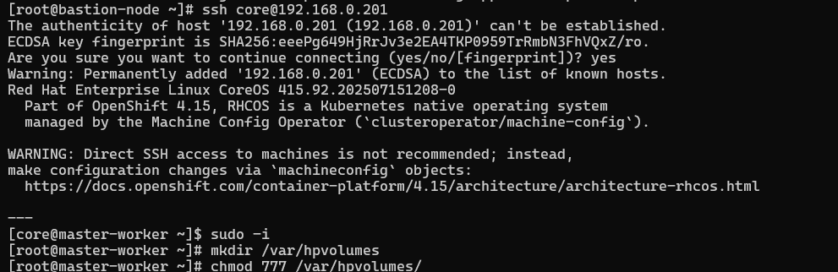

The yaml need to look like this
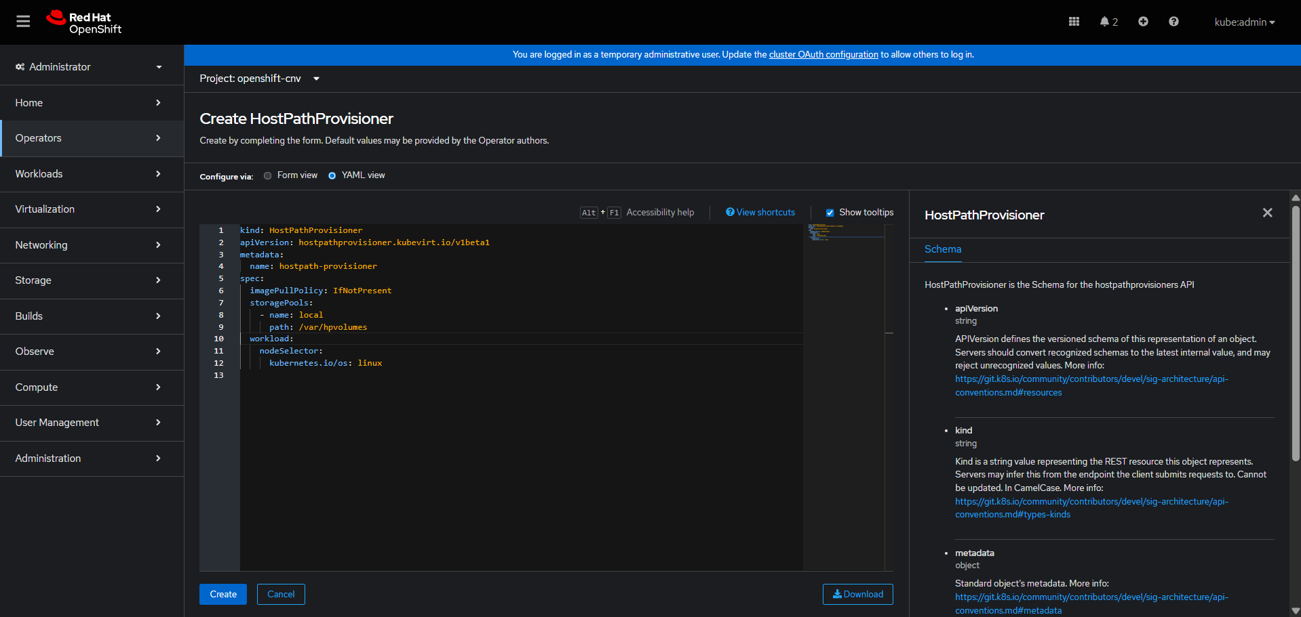
And create the hpp. Wait till the hpp is in avalaible state.
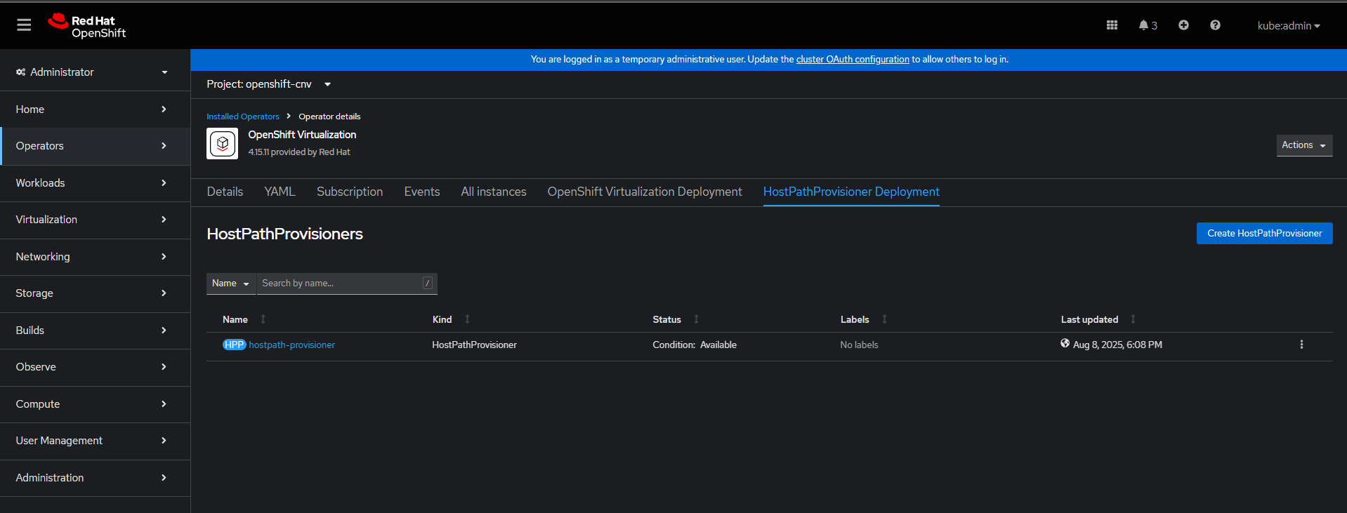

StorageClass instance creation with custom configuration
- Create a storage class with Provisioner as hostpath-provisoner.
- Select additional parameter as stroagePool=local
- Annotate the storage class as default.
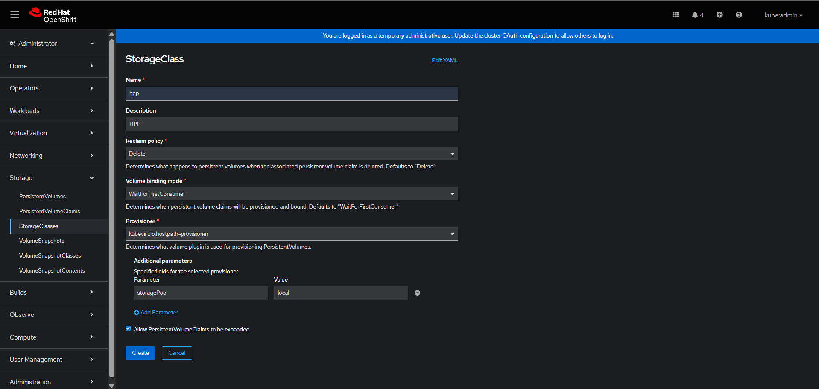
oc annotate storageclass hpp storageclass.kubernetes.io/is-default-class="true"
hpp should be in default.

Internal image registry operator config changes.
- Configure the internal image registry
- $ oc edit configs.imageregistry.operator.openshift.io

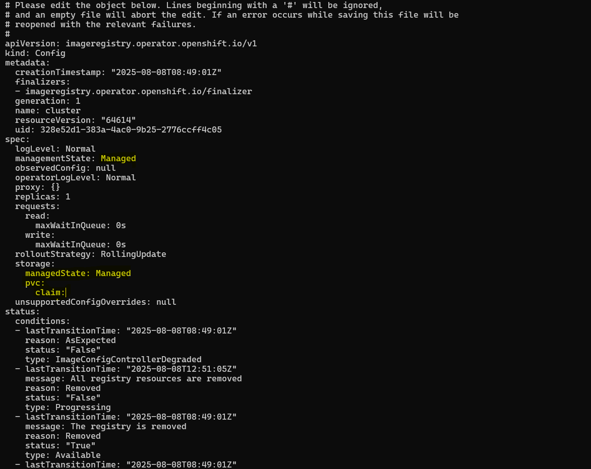
- Check oc get pods -n openshift-image-registry
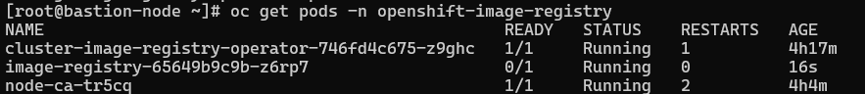
- oc get dv -A to verify the ImportScheduled or not
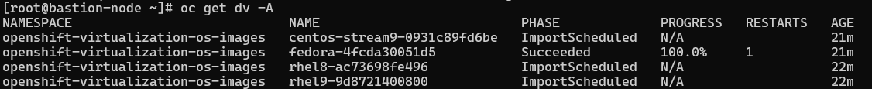
- Check PVC whether pvc is in bound state or not. If not then wait till it bound.
